Bdm 221: DATA SCIENCE

# ASSIGNMENT 2

## QUESTION:

Create a linear regression model for analyzing road accident severity using the relevant dataset related to the scenario, Please specify the dependent variable (the variable you want to predict) and the independent variables (the factors that influence the accident severity). After creating the model, save it for future use. Then, provide an example of using the model to predict accident severity for a hypothetical set of independent variables, and explain how such a model could be beneficial for traffic accident analysis and prevention in underdeveloped countries. Add all relevant screen shots as well from your program. Also share the URL of your GITHUB (Where you have uploaded your work) so that I can simulate the same.

## ANSWERS:

1. **Dependent Variable:**

* accident_severity: This is the variable

**Independent Variables:**

* vehicle_speed
* time_of_day
* num_vehicles
* driver_age
* weather_conditions (one-hot encoded into: weather_conditions_rainy, weather_conditions_foggy, weather_conditions_snowy)
* road_surface (one-hot encoded into: road_surface_wet, road_surface_icy)
* road_type (one-hot encoded into: road_type_residential, road_type_urban)

2. 

Figure : Save the Model for Future Use

3. 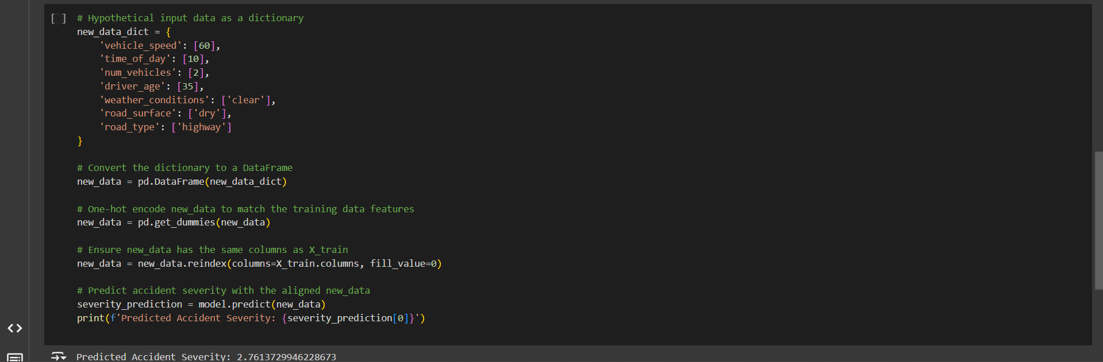

Figure : Example Prediction with Hypothetical Data

4. Using a linear regression model to analyze road accident severity can be highly valuable for underdeveloped nations by supporting data-driven decisions in traffic safety and infrastructure planning. Here’s how this type of model can offer benefits:

**i. Recognizing Key Risk Factors**

* The model can reveal which elements most influence accident severity, such as vehicle speed, road condition, or time of day. For example, if results indicate that accidents are more severe at higher speeds on wet surfaces, authorities could emphasize speed control and drainage improvements in particularly vulnerable areas.
* With these insights, policymakers can concentrate limited resources on the most impactful safety strategies, prioritizing measures like road upgrades or targeted driver-awareness initiatives.

**ii. Strategic Resource Allocation**

* By predicting severity levels under various conditions (e.g., different weather patterns or road types), city planners and traffic authorities can proactively assign resources like patrols, warning signs, or emergency services to high-risk areas.
* This anticipatory approach can reduce accidents by addressing factors that increase severity risk under specific conditions, mitigating them before they escalate.

**iii. Informed Traffic Safety Policies**

* Model insights can support establishing data-backed traffic rules, such as limiting speeds on highways with high severity risk or restricting heavy vehicles in residential areas.
* Traffic agencies might also time road maintenance projects during non-peak hours, thereby minimizing exposure to high-risk conditions based on the model’s guidance.

**iv. Focused Community Awareness and Driver Education**

* Analysis from the model could help structure community campaigns that address specific factors increasing severity. For example, informing drivers about the heightened risks of high-speed driving in fog or the dangers associated with younger drivers speeding at night.
* Regional data can be used to create public announcements that result in safer driving behaviors, especially in regions with historically higher accident rates.

**v. Policy and Infrastructure Planning Improvements**

* Policymakers can use model insights to advocate for targeted infrastructure enhancements like better lighting, improved signage, or modifications at hazardous intersections.
* Long-term city planning decisions may also be shaped by these analyses, guiding the creation of bypasses, overpasses, or more structured intersections in high-accident areas.

**vi. Cost-Effective Solutions**

* Limited budgets for road safety in underdeveloped countries make it essential to focus on impactful, affordable measures. Predictive models allow these nations to focus on high-impact improvements, making every safety investment more efficient and meaningful.